**PIZZA SALES SQL QUERIES**

**A. KPI’s**

**1. Total Revenue:**

SELECT SUM(total_price) AS Total_Price FROM pizza_data;

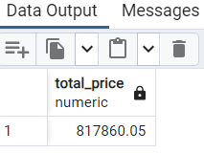

**2. Average Order Value**

SELECT (SUM(total_price) / COUNT(DISTINCT order_id)) AS Average FROM pizza_data;

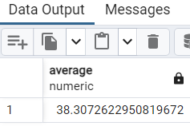

**3. Total Pizzas Sold**

SELECT SUM(quantity) AS Total_pizza_sold FROM pizza_data;

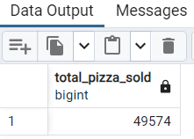

**4. Total Orders**

SELECT COUNT(DISTINCT order_id) AS Total_Order FROM pizza_data;

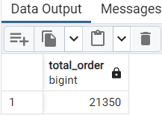

**5. Average Pizzas Per Order**

SELECT CAST(CAST(SUM(quantity) AS DECIMAL(10,2)) /

CAST(COUNT(DISTINCT order_id) AS DECIMAL(10,2)) AS DECIMAL(10,2))

AS Avgerage_Pizza_sold_per_order

FROM pizza_data;

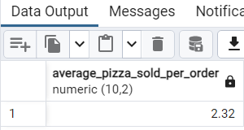

**B. Daily Trend for Total Orders**SELECT TO_CHAR(order_date,‘Day’) AS order_day, COUNT(DISTINCT order_id)

FROM pizza_data

GROUP BY order_day;

***Output:***

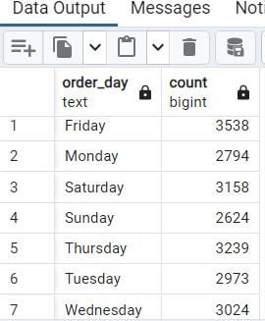

**C. Monthly Trend for Orders**

SELECT TO_CHAR(order_date,’Month’) as Month_order, COUNT(DISTINCT order_id) AS total_Order

FROM pizza_data

GROUP BY Month_order;

***Output***

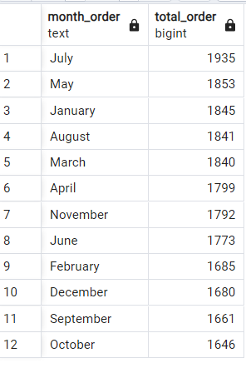

**D. % of Sales by Pizza Category**

SELECT pizza_category, SUM(total_price) AS total_price,

SUM(total_price) * 100 / (SELECT SUM(total_price) FROM pizza_data) AS PCT

FROM pizza_data

GROUP BY pizza_category;

***Output***

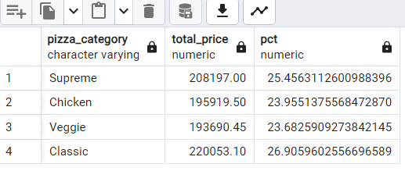

**E. % of Sales by Pizza Size**

SELECT pizza_size, SUM(total_price) as Total_price,

CAST(SUM(total_price) * 100 / (SELECT SUM(total_price) from pizza_data) AS DECIMAL(10,2)) AS PCT

FROM pizza_data

GROUP BY pizza_size

ORDER BY Total_price desc;

***Output***

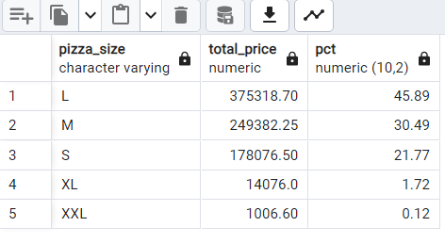

**F. Total Pizzas Sold by Pizza Category**

SELECT pizza_category, SUM(quantity) as Pizza_sold

FROM pizza_data

GROUP BY pizza_category

ORDER BY Pizza_sold DESC;

***Output***

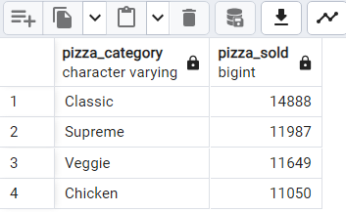

**G. Top 5 Pizzas by Revenue**

SELECT pizza_name, SUM(total_price) AS Total_price

FROM pizza_data

GROUP BY pizza_name

ORDER BY Total_price DESC LIMIT 5;

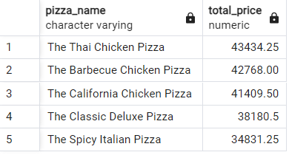

**H. Bottom 5 Pizzas by Revenue**

SELECT pizza_name, SUM(total_price) AS Total_price

FROM pizza_data

GROUP BY pizza_name

ORDER BY Total_price ASC LIMIT 5;

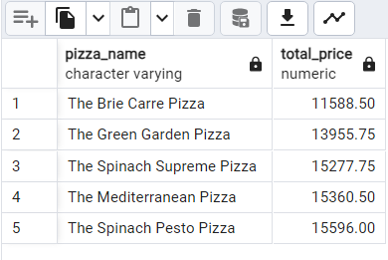

**I. Top 5 Pizzas by Quantity**

SELECT pizza_name, SUM(quantity) AS Total_quantity

FROM pizza_data

GROUP BY pizza_name

ORDER BY Total_quantity DESC LIMIT 5;

***Output***

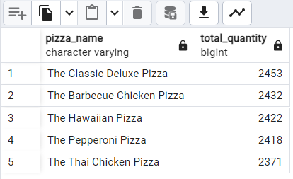

**J. Bottom 5 Pizzas by Quantity**

SELECT pizza_name, SUM(quantity) AS Total_quantity

FROM pizza_data

GROUP BY pizza_name

ORDER BY Total_quantity ASC LIMIT 5;

***Output***

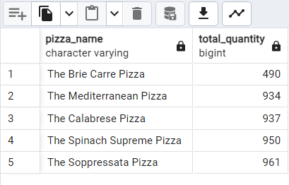

**K. Top 5 Pizzas by Total Orders**

SELECT pizza_name, COUNT(DISTINCT order_id) AS Total_Order

FROM pizza_data

GROUP BY pizza_name

ORDER BY Total_Order DESC LIMIT 5

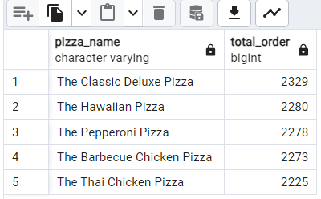

**L. Bottom 5 Pizzas by Total Orders**

SELECT pizza_name, COUNT(DISTINCT order_id) AS Total_Order

FROM pizza_data

GROUP BY pizza_name

ORDER BY Total_Order ASC LIMIT 5

